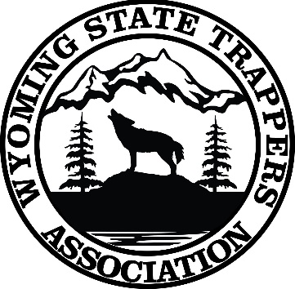

Wyoming State Trappers Association Scholarship Application Form

WHO WE ARE –
The Trappers of Wyoming, joined together to create a more effective voice through cooperative efforts in the conservation and management of Wyoming’s fur bearing animals. In the developments and applications of proper and effective predator control methods, and to develop and maintain the public image of trapping as a legitimate, desirable and compatible enterprise of modern man; to stimulate an increased understanding and awareness of the; impact of modern society and man on his environment; and to encourage citizens, legislative and administrative action towards the protection and restoration of our natural and historical heritage, and the creation of trapper attitudes which reflect these values, through creative planning and education. We believe education is important at every aspect of life.

AVAILABLE SCHOLARSHIP-
Two (2) $1,000 Scholarships payable upon proof of enrollment to a post-secondary school or vocational school. It will be issued to institution in recipient’s name. And one year family membership to WSTA.

APPLICATION CRITERIA-
- Must be Accepted to a college or trade school within 12 months of scholarship.
- 2 Letters of Recommendation from non-family members i.e. teacher or counselor
- 500-word essay on what trapping, and wildlife conservation means to you
- Include any volunteering, or extra-curricular activities you participated in.
- Open to traditional or non-traditional students
- Application must be submitted /postmarked no later than May 1
- Recipients will be notified of award between May 15-May 30

Mail to: WSTA
PO BOX 83
BAGGS, WY 82321 or
email to: contactus@wyotrap.com
NAME: _____________________________________________________
ADDRESS: __________________________________________________________
Phone #: _________________ Email:_____________________________________

