***WYOMING TRAPPERS ASSOCIATION***

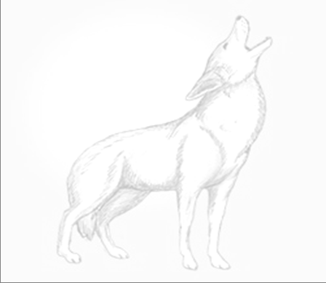***MEMBERSHIP APPLICATION***

Lifetime $500.00

Family (residing at same address) $50.00 per year

Adult Membership $40.00 per year

Adult Membership w/o Magazine $30.00 per year

15 and under $12.00 per year

***MAIL TO:***

*Wyoming Trappers Association*

*P O Box 83*

*Baggs, WY 82321*

Date_________________

*NAME _______________________________________________________________________*

*ADDRESS ____________________________________________________________________*

*CITY _______________________ STATE ____________________ ZIP _________________*

*PHONE ____________________________ E-MAIL __________________________________*

***WYOMING TRAPPERS ASSOCIATION***

***MEMBERSHIP APPLICATION***

Lifetime $500.00

Family (residing at same address) $50.00 per year

Adult Membership $40.00 per year

Adult Membership w/o Magazine $30.00 per year

15 and under $12.00 per year

***MAIL TO:***

*Wyoming Trappers Association*

*P O Box 83*

*Baggs, WY 82321*

Date_________________

*NAME _______________________________________________________________________*

*ADDRESS ____________________________________________________________________*

*CITY _______________________ STATE ____________________ ZIP _________________*

*PHONE ____________________________ E-MAIL __________________________________*